**DESIGN AND CONSTRUCTION OF AN INTELLIGENT POWER SOURCE SELECTOR FOR IMPROVED RELIABILITY AND EFFICIENCY OF A MICROGRID**

BY

**AKINLADE, JOSEPH OLUWADARA**

**MATRICULATION NUMBER: 206429**

UNDER THE SUPERVISION OF

**DR. T.R AYODELE**

**A PROJECT REPORT SUBMITTED TO THE**

**DEPARTMENT OF ELECTRICAL & ELECTRONIC ENGINEERING,**

**FACULTY OF TECHNOLOGY, UNIVERSITY OF IBADAN.**

IN

**PARTIAL FULFILLMENT OF THE REQUIREMENTS FOR THE AWARD OF BACHELOR OF SCIENCE DEGREE IN ELECTRICAL AND ELECTRONIC ENGINEERING OF THE UNIVERSITY OF IBADAN, IBADAN**

**JULY, 2023**

# CERTIFICATION

This is to certify that the project upon which this report is based was carried out by **AKINLADE, JOSEPH OLUWADARA** of the Department of Electrical and Electronic Engineering, Faculty of Technology, University of Ibadan.

**PROJECT SUPERVISOR:**

**DR. T.R AYODELE: ……………………………………………………….**

**Signature with date: …………………………………………………………**

**HEAD OF DEPARTMENT:**

**DR. O.O OLAKANMI: ……………………………………………………….**

**Signature with date: ……………………………………………………………**

# dedication

I dedicate this work report to those who have been instrumental in my academic journey. Firstly, I am grateful to God for His guidance and protection throughout this journey. To my family, your unwavering love, support, and encouragement have been my pillar of strength. Thank you for being my rock, believing in me and my dreams, and constantly pushing me to be my best. I also extend my gratitude to my academic advisors and the faculty members of the Department of Electrical and Electronic Engineering for their valuable guidance, and constructive feedback, and for providing a conducive learning environment. Finally, to my colleagues and friends, thank you for your camaraderie, support, and for making this academic journey more enjoyable. This work report is a culmination of everyone's effort and support, and I am thankful for each and every one of you.

# ACKNOWLEDGEMENT

I would like to express my heartfelt gratitude to several individuals who have played a pivotal role in making this project a success.

Firstly, I am deeply grateful to my supervisor, Dr. T.R Ayodele, for his invaluable guidance, support, and mentorship throughout this journey. His expertise, patience, and encouragement have been instrumental in shaping the direction and scope of this project.

I would also like to extend my sincere appreciation to the staff and faculty members of the Electrical and Electronic Engineering for their assistance and resources that were made available to me. Their academic and technical support has been essential in enabling me to carry out this research work.

I am also grateful to my family for their unwavering support, love, and encouragement. Their understanding and motivation have kept me grounded throughout this journey, and I could not have achieved this milestone without their support.

I would also like to thank my friends and colleagues, especially Raji Olaoluwa, for their support, advice, and encouragement along the way. Your insights and feedback have been instrumental in shaping the direction of this project, and I am grateful for the privilege of working with such an amazing group of people.

Finally, I want to acknowledge the grace of God, who has been my source of strength, wisdom, and inspiration throughout this journey. I thank Him for the opportunity to undertake this project and for His continuous guidance and blessings.

Thank you all for your contributions and support.

# ABSTRACT

Intelligent Power Source Selector (IPSS) systems have become increasingly popular in recent years, as they enable the efficient and cost-effective management of multiple power sources in a microgrid. This report presents the design and implementation of an IPSS system for a microgrid consisting of Solar, Wind, and Diesel generators.

Chapter 1 provides an introduction to the concept of microgrids and their benefits, as well as the motivation for the research project. It also outlines the objectives and scope of the study.

Chapter 2 discusses the literature review on the different types of power sources, their advantages and disadvantages, and the existing power source selection techniques. It also explores the concept of intelligent power source selection and the factors that should be considered when selecting a power source.

Chapter 3 describes the methodology used in designing and implementing the IPSS system, including the selection of sensors, the decision-making process, the software and hardware implementation.

Chapter 4 presents the results of the experiments carried out to test the performance of the IPSS system, as well as a comparison with a traditional generation method that uses a diesel generator only to power the microgrid. The results show that the IPSS system significantly improves the reliability and cost-effectiveness of the microgrid.

Chapter 5 concludes the report and provides recommendations for future work, such as the integration of battery storage and the use of machine learning algorithms to improve the decision-making process in the IPSS system.

TABLE OF CONTENTS

CERTIFICATION i

DEDICATION ii

ACKNOWLEDGEMENT iii

ABSTRACT iv

LIST OF FIGURES viii

LIST OF TABLES ix

CHAPTER 1 1

INTRODUCTION 1

1.1 BACKGROUND OF STUDY 1

1.2 PROBLEM STATEMENT 2

1.3 AIM 2

1.4 OBJECTIVES 2

1.5 PROJECT ORGANIZATION 3

CHAPTER 2 4

LITERATURE REVIEW 4

2.1 INTRODUCTION 4

2.2 BACKGROUND AND RELATED WORK 4

2.3 POWER MANAGEMENT SYSTEMS 6

2.4 MICROGRID TYPES AND CHARACTERISTICS 9

2.5 POWER SOURCE SELECTORS 11

2.6 IMPROVING RELIABILITY AND EFFICIENCY OF A MICROGRID 13

2.7 CONCLUSION 15

CHAPTER 3 16

METHODOLOGY 16

3.1 INTRODUCTION 16

3.2 SYSTEM ARCHITECTURE 17

3.2.1 SCHEMATIC DIAGRAM OF A UNIT IN THE MICROGRID 18

3.2.2 SCHEMATIC DIAGRAM OF THE IPSS SYSTEM 19

3.3 SYSTEM HARDWARE COMPONENTS 20

3.3.1 Arduino Nano Development board 20

3.3.2 PZEM-004Tv30 metering module 22

3.3.3 HC-12 Transceiver module 24

3.3.4 Power Supply of a unit in the microgrid 26

3.3.5 ESP32 Microcontroller 28

3.3.6 20X4 Liquid Crystal Display (LCD) 30

3.3.7 DS1302 Real-time clock module 32

3.3.8 LEDS 34

3.3.9 Power Supply (IPSS) 35

3.4 SYSTEM SOFTWARE COMPONENT 37

3.4.1 Data Receiver Module 37

3.4.2 Intelligent Power Source Selector (IPSS) Algorithm 38

3.4.3 Real-time clock module 39

CHAPTER 4 41

RESULTS AND DISCUSSIONS 41

4.1 INTRODUCTION 41

4.2 IPSS SYSTEM PERFORMANCE 41

4.3 COMPARISON WITH TRADITIONAL POWER GENERATION METHODS 44

CHAPTER 5 48

CONCLUSION AND RECOMMENDATION 48

5.1 CONCLUSION 48

5.2 RECOMMENDATION 48

APPENDIX 50

REFERENCES 60

# LIST OF FIGURES

Figure 3.1: Block diagram of a unit in the microgrid 17

Figure 3.2: Block diagram of the Intelligent Power Source Selector 17

Figure 3.3: Schematic diagram of a unit in the microgrid 18

Figure 3.4: Schematic diagram of the Intelligent Power Source Selector 19

Figure 3.5: Arduino Nano Development board 21

Figure 3.6: PZEM-004Tv30 Metering module 23

Figure 3.7: HC-12 Transceiver Module 25

Figure 3.8: 5V voltage regulator (L7805) 27

Figure 3.9: Lithium-ion batteries 27

Figure 3.10: ESP32 Microcontroller 30

Figure 3.11: 20 x 4 LCD Display 32

Figure 3.12: DS1302 RTC module 33

Figure 3.13: Light Emitting Diodes (LEDs) 35

Figure 3.14: LM2596 buck converter 36

Figure 3.15: Data Receiver Module 38

Figure 3.16: Flowchart of the software component of the IPSS system 40

Figure 4.1: Working prototype of the Intelligent Power Source Selector 47

# list of tables

Table 3.1: Specifications of Arduino Nano Microcontroller 22

Table 3.2: Specification of PZEM-004Tv30 Metering module 24

Table 3.3: Specification of the HC-12 transceiver module 26

Table 3.4: Specification of L7805 voltage regulator 28

Table 3.5: Specifications of the ESP32 microcontroller 30

Table 3.6: Specification of the 20 x 4 LCD Display 32

Table 3.7: Specification of the DS1302 RTC module 34

Table 3.8: Specifications of the LM2596 buck converter 36

Table 4.1: Power output profiles of the sources used in the microgrid 41

Table 4.2: IPSS system performance for a 24-hour period 43

Table 4.3: Comparison between IPSS system and Traditional Power generation methods 44

Table 5.1: List of Materials Used 50

# 

# Introduction

## BACKGROUND OF STUDY

Smart microgrids are decentralized electrical power systems that are designed to provide reliable and affordable power to a specific geographic area, such as a campus, neighborhood, or military base. They are typically composed of a combination of power sources, such as the grid, renewable energy sources such as solar or wind, and backup generators, and are equipped with intelligent control systems to coordinate the generation, distribution, and consumption of power.

The adoption of renewable energy sources, such as solar and wind, has increased in recent years due to their potential to reduce reliance on fossil fuels and mitigate the environmental impacts of electricity generation. However, renewable energy sources can be intermittent and unpredictable and are often supplemented with backup generators or the grid to ensure a reliable power supply. This creates a complex and dynamic power system that requires careful coordination and management to optimize power usage, reduce costs, and maintain reliability.

An intelligent power source selector is a system that is able to automatically select the most appropriate power source for a given load based on various criteria such as cost, reliability, and environmental impact. By intelligently selecting the power source, an intelligent power source selector can help to optimize power usage, reduce costs, and increase the reliability of the power supply in a smart microgrid.

For example, an intelligent power source selector might prioritize the use of renewable energy sources when they are available and cost-effective, and switch to backup generators or the grid when the renewable energy sources are unavailable or unable to meet the demand. This can help to reduce the overall cost of power, as renewable energy sources are often cheaper than fossil fuels in the long run. At the same time, the intelligent power source selector can ensure that the power supply remains reliable by switching to backup sources as needed, and can also

help to reduce the environmental impacts of the power systems by reducing the use of fossil fuels.

In summary, the use of an intelligent power source selector can help to optimize power usage, reduce costs, and increase the reliability and sustainability of the power supply. This makes it an important and valuable technology for improving the efficiency and performance of smart microgrids.

## PROBLEM STATEMENT

The selection of the most appropriate power source for a given load can be a complex and time-consuming task, particularly in a smart microgrid where multiple power sources are available. Each of the power sources have their own unique characteristics and limitations, such as capacity, efficiency, availability, and cost, and selecting the most appropriate power source requires careful consideration of these factors. In addition, manually selecting the power source can lead to inefficiencies in power usage and higher costs, and can impact the reliability of the power supply.

## AIM

This project aims to design and construct an intelligent power source selector for a smart microgrid application.

## OBJECTIVES

The objectives of this project are to:

1. Evaluate the various power sources available in a smart microgrid and their respective characteristics.
2. Design and implement an intelligent power source selector algorithm that considers the time of the day, total power demand, and availability of power sources to determine the most cost-effective source or combination of sources.
3. Compare the cost-effectiveness of the intelligent power source selector with a traditional system that relies solely on a diesel generator.

## PROJECT ORGANIZATION

The first chapter introduces the background of the project, aim and objectives of the project.

The second chapter describes the literature review on smart microgrids and intelligent power source selection.

The third chapter presents the methodology used in the study, including the system design and implementation, simulation and experimentation setup, and performance evaluation metrics.

The fourth chapter presents the results of the simulation and experimentation, the implications of these results.

The fifth chapter presents the conclusions of this study and proposes directions for future work.

# 

# LITERATURE REVIEW

## INTRODUCTION

The increasing demand for reliable and efficient power supply has led to the development of microgrids, which are small-scale power systems that can be operated with, or independently of the main grid. Microgrids provide a sustainable and cost-effective solution for remote and rural areas, as well as for hospitals, and military bases. However, the effective management of power sources and loads is essential to ensure the reliability and efficiency of microgrids.

Power source selection is a critical aspect of microgrid operation, as it determines the power quality and availability of the system. Intelligent power source selectors can improve the reliability and efficiency of microgrids by selecting the most suitable power source based on the system’s load demand and availability. This literature review aims to critically analyze existing research on intelligent power source selectors for microgrids and identify current knowledge gaps. The review will also provide a context for the proposed project on the development of an intelligent power source selector for a microgrid.

In this literature review, a background on microgrids, power management systems, and power source selectors will first be provided. Then, the different types of microgrids and their characteristics, advantages, and limitations will be discussed. Next, various methods and techniques that have been used to improve the reliability and efficiency of microgrids, with a focus on power source selection will also be discussed.

This literature review will contribute to the understanding of intelligent power source selectors and their application in microgrids, and will provide a foundation for future research in this area.

## BACKGROUND AND RELATED WORK

Intelligent power source selectors have been proposed as a means of improving the reliability and efficiency of microgrids by selecting the most suitable power source based on the system’s load demand and power source availability. These systems use advanced algorithms and sensors to monitor the microgrid’s power sources and loads and automatically switch between power sources to ensure optimal performance.

Several research studies have investigated the use of intelligent power source selectors in microgrids, and have demonstrated the potential benefits of these systems in improving the reliability and efficiency of microgrids.

In (Kong & Liu 2016), GreenPlanning was presented as a framework to strike a judicious balance among multiple energy sources, grid power, and energy storage device for a data center. GreenPlanning investigates different features and operations of a wide spectrum of renewable energy sources and traditional energy sources available to data centers. The framework minimizes the lifetime total cost, including both capital and operational cost for a data center. Results demonstrated that GreenPlanning can reduce the lifetime total cost and emission by more than 50% compared to traditional configurations, while still satisfying service availability requirements.

In (Ma et al. 2016), a switched system approach is employed to ensure the stability of a dc microgrid with a rich array of operating modes. An optimal control algorithm was designed to improve the system performance by appropriately selecting the operation modes. This system was shown to improve the stability of a dc microgrid while minimizing its operation cost.

In (Avikal et al., 2020), a fuzzy AHP (Analytic Hierarchy Process) and TOPSIS (Technique for order of preference by similarity to Ideal Solution) based approach were proposed for a microgrid, which considered various factors such as cost, air and noise pollution, and reliability. The results from this approach gave assured reliability and sustainability for remote areas using a photovoltaic (PV)-diesel generator hybrid energy system.

Smart Home Energy Management Systems (HEMS) are being employed to optimize the consumption of electricity based on load demand and renewable energy forecasts. It is essential for a smart HEMS to ensure the right energy mix by optimizing the power consumption from the local resources and the main grid in order to improve efficiency and reduce the overall cost of the system. In (Kumar et al. 2020), a smart HEMS was proposed that implements this idea using an optimal source selection algorithm. The proposed system comprised two input sources which were a PV-battery duo source and the main electricity grid. The system takes into consideration the electricity price information, user load profile, solar irradiance profile, and battery power output information. The input information is used to select the right power source for every home’s load to ensure the right mix and reduce the overall cost of electricity.

In (Ani, 2021), a power management system that will control the power flow of an integrated renewable energy system with a focus on solar energy, wind energy, and dual-energy storage systems (batteries are used as the primary energy storage system for short to moderate storage term, whereas hydrogen fuel cell is used as a backup and long-term energy storage) is developed. These storage systems are needed to provide high reliability and control systems and are necessary for the stable and optimal operation of the whole system. Also, an intelligent power management system (IPMS) is developed to handle various changes in power supply and power demand by managing erratic power and providing a suitable control algorithm for the whole system. In order to test and validate the proposed IPMS model, simulations were conducted under various power supplies and power demands using a system modeled in HOMER environment. The performed simulations confirm the ability of the IPMS to satisfy the load at all times using solar and wind power (which are unsteady renewables), through the support of batteries and hydrogen fuel cells without a reduction in the power quality or load supply.

## POWER MANAGEMENT SYSTEMS

Power Management Systems (PMS) are essential components of microgrids as they coordinate and manage the power sources and loads within the microgrid. A PMS typically includes control algorithms, sensors, and communication systems that enable the management of power flows between different power sources and loads.

The primary objective of a PMS is to ensure the reliable and efficient operation of the microgrid. To achieve this, the PMS needs to balance the supply and demand of power within the microgrid by optimizing the operation of the power sources and loads. The PMS also needs to ensure the stability and quality of the power supply by regulating the voltage and frequency levels within the microgrid.

Several studies have proposed different approaches for designing and implementing PMS for microgrids. In (Trifkovic et al., 2012), a hierarchical power management system for a hybrid renewable energy system (HRES), is implemented, comprising a supervisory controller, which ensures the power balance between intermittent renewable energy generation, energy storage, and dynamic load demand, and local controllers for the photovoltaic (PV), wind, electrolyzer, and fuel cell units. A decentralized model predictive control (MPC) was also designed and implemented on the electrolyzer and fuel cell to ensure optimal power flow.

In (Hosseinzadeh & Salmasi 2015), a robust optimal power management system is developed for a hybrid AC/DC microgrid, where the power flow in the microgrid is supervised based on solving an optimization problem. Satisfying demanded power with maximum utilization of renewable resources, minimum usage of fuel-based generators, extending battery lifetime, and limited utilization of the main power converter between the AC and DC microgrids are important factors that are considered in the approach. Uncertainties in the resources output power and generation forecast errors, along with static and dynamic constraints of the resources are taken into account. Also, since uncertainties in resources output power may result in fluctuations in the DC bus voltage, a two-level controller is used to regulate the charge/discharge of the battery banks. The effectiveness of the proposed supervisory system is evaluated through extensive simulations run based on dynamic models of the power resources.

In (Katiraei & Iravani, 2006), real and reactive power management strategies of electronically interfaced distributed generation (DG) units in the context of a multiple-DG microgrid system are examined. The focus was primarily on electronically interfaced DG (EI-DG) units, with controls and power management strategies based on locally measured signals without communications. Three power management strategies based on the reactive power controls adopted were identified and investigated. They were Voltage-droop characteristics, voltage regulation, and load-reactive power compensation. The real power of each DG unit is controlled on a frequency-droop characteristic and a complementary frequency restoration strategy. A systematic approach to developing a small-signal dynamic model of a multiple-DG microgrid, including real and reactive power management strategies was presented. This model was used to investigate the microgrid dynamic behavior, select control parameters of DG units, and incorporate power management strategies in the DG controllers. The paper also discusses the sensitivity of the design to changes in parameters and operating points, as well as the optimization of the microgrid system’s performance. The results were used to explore the applications of the proposed power management strategies under various microgrid operating conditions.

In (Belmokhtar & Higuita Cano, 2021), a novel fuzzy logic-based PMS technique was presented for the remote microgrid (MG) system that included wind, PV, and diesel generators. The main objective of this technique was to improve the reliability of the system, increase renewable energy source (RES) integration, and enhance the reactive and active power performance of the microgrid system with the help of AI algorithms. The researchers assessed the performance of their proposed PMS technique with regard to the regulation of the active and reactive powers. For sharing a diesel generator based on the fuzzy logic for the active and reactive powers, the researchers proposed two simulation scenarios. The first scenario was based on the stepped solar irradiation and wind speed profiles, while the second scenario was based on the solar irradiation and wind speed continuous profile. Results showed that this algorithm achieved better stability and reliability of the microgrid system. Furthermore, the active and reactive power control algorithm showed a faster response to various activities related to the remote microgrid, such as frequency and rapid voltage fluctuations related to the AC link system.

In (Faria et al., 2019), an artificial neural network (ANN)-based PMS was proposed for the standalone microgrid that included batteries, PVs, and supercapacitors. The objective function of the study was to minimize stress on battery storage and maximize its lifespan. A PV model can be used for validating and assessing the performance of the algorithm. The researchers noted that this technique improved the life span of the battery as it could decrease the dynamic stress and peak current. Additionally, it maximized the supercapacitor utilization.

## MICROGRID TYPES AND CHARACTERISTICS

Microgrids are small-scale power grids that can operate independently or in parallel with the main power grid. They typically consist of a combination of distributed energy sources (DERs), such as solar panels, wind turbines, energy storage systems, and backup generators, as well as control systems and communication networks. Microgrids are designed to provide reliable, resilient, and cost-effective electricity to customers, communities, or facilities.

Microgrids are gaining popularity due to their potential to address some of the challenges associated with traditional centralized power grids, such as increasing energy costs, power outages, and vulnerability to natural disasters. They also offer opportunities for integrating renewable energy sources and reducing greenhouse gas emissions.

There are several types of microgrids, which can be categorized based on their connection to the main grid and primary source of energy. Here are some common types of microgrids:

1. Grid-connected microgrids: These microgrids are connected to the main grid and can either operate in parallel with the grid or as a backup power source when the grid fails. They typically use renewable energy sources, such as solar or wind power, along with energy storage systems, such as batteries.

Benefits:

1. It reduces electricity costs by utilizing renewable energy sources and energy storage systems.
2. It increases grid stability and reliability by providing backup power during grid outages.
3. It reduces greenhouse gas emissions by integrating renewable energy sources.

Challenges:

1. Dependence on the main grid may limit the ability to operate independently during grid outages.
2. Complexity of control systems and regulatory requirements may add to the cost and difficulty of implementation.
3. Islanded microgrids: These microgrids are not connected to the main grid and operate independently, typically in remote or off-grid areas. They rely on local sources of energy, such as diesel generators, or renewable energy sources like solar or wind power.

Benefits:

1. It provides reliable and independent power supply in remote or off-grid areas.
2. It reduces dependence on expensive and polluting diesel generators by utilizing renewable energy sources.
3. It can be customized to meet the specific needs of a community or facility.

Challenges:

1. Higher upfront cost due to the need for local energy sources and energy storage systems.
2. Limited scalability and potential for low utilization rates in areas with low energy demand.
3. Hybrid microgrids: These microgrids combine different sources of energy, such as diesel generators, solar power, wind power, and energy storage systems, to provide reliable and cost-effective power. They are particularly useful in areas with fluctuating energy demand or unreliable grid connections.

Benefits:

1. It provides reliable and cost-effective power by utilizing a combination of energy sources.
2. It increases the resilience and reduce the vulnerability to energy supply disruptions.
3. It reduces the dependence on fossil fuels and reduce greenhouse gas emissions.

Challenges:

1. Higher upfront cost due to the need for local energy sources and energy storage systems.
2. Limited scalability and potential for low utilization rates in areas with low energy demand.
3. AC microgrids: These microgrids use alternating (AC) power and are similar to traditional power grids. They are more common in urban or suburban areas and can be used to supplement or replace the existing power grid.

Benefits:

1. It can easily be integrated with the existing power grid and infrastructure.
2. It provides a familiar and easy-to-use power supply for customers.

Challenges:

1. Dependence on the main grid may limit the ability to operate independently during grid outages.
2. DC microgrids: These microgrids use direct current (DC) power and are becoming more popular in buildings, data centers, and other applications where DC power is more efficient or where there are high levels of DC loads.

Benefits:

1. It provides a more reliable power supply for critical loads.
2. It can be customized to meet the specific needs of the building or application.

Challenges:

1. Higher upfront cost due to the need for specialized equipment and components
2. Complexity of control systems and energy management may add to the cost and difficulty of implementation.

## POWER SOURCE SELECTORS

Power source selectors are devices that allow multiple power sources to be connected to a load, and they are used to ensure a continuous and stable supply of power. They automatically or manually switch between different power sources based on certain conditions, such as voltage levels, frequency, or availability. Some common types of power source selectors are:

1. Manual switches: These are simple mechanical switches that allow the user to manually select between different power sources. They are easy to use and cost-effective but require manual intervention and may not be suitable for critical applications.
2. Automatic transfer switches (ATS): They are commonly used in residential, commercial, and industrial applications. They can automatically switch between the main power grid and backup generators or other sources in cases of power outages or other disruptions. They are reliable and efficient but can be expensive and require regular maintenance.
3. Static transfer switches (STS): STSs are similar to ATSs but use solid-state technology to transfer power between sources. They can switch faster and more reliably than ATSs and are often used in mission-critical applications such as data centers and hospitals. However, they are more expensive than ATSs and may require specialized expertise to install and maintain.
4. Load shedding systems: Load shedding systems are used to manage power demand during periods of high energy consumption or limited power availability. They can automatically or manually switch off non-essential loads to balance the power demand with the available supply. They are cost-effective but may require additional backup power sources to maintain critical loads.

When selecting a power source selector, several factors should be considered, including:

1. Power requirements: The power source selector should be capable of supplying the required power to the load and have sufficient capacity to handle peak loads.
2. Compatibility: The power source selector should be compatible with the power sources and loads being connected, including voltage, frequency, and phase requirements.
3. Reliability: The power source selector should be reliable and capable of operating in harsh environments, with minimal downtime and maintenance requirements.
4. Safety: The power source selector should comply with relevant safety standards and regulations and have built-in protection features such as overvoltage and overcurrent protection.
5. Cost: The power source selector should be cost-effective and balance performance and price well.

## IMPROVING RELIABILITY AND EFFICIENCY OF A MICROGRID

Reliability and Efficiency are two important factors that must be considered in any microgrid system. With the increasing demand for clean and sustainable energy sources, microgrids are gaining popularity as an alternative to traditional power grids. However, microgrids face several challenges that affect their reliability and efficiency, such as the need for energy storage solutions, communication network limitations, and control system complexities.

To overcome these challenges, researchers have proposed several solutions aimed at improving the performance of microgrid systems. (Abdulgalil & Khalid, 2019) illustrate how to optimally size an Energy storage system (ESS) to be integrated with a grid-connected microgrid using the mixed-integer linear programming method. Results showed that sizing the ESS optimally enhanced the reliability of the power system with notable differences.

In (Atwa et al., 2010), a method was proposed for optimally allocating different types of renewable distributed generation (DG) units in the distribution system so as to minimize annual energy loss. The method was based on generating a probabilistic generation-load model that combines all possible operating conditions of the renewable DG units with their probabilities, hence accommodating this model in a deterministic planning problem. The planning was formulated as mixed integer nonlinear programming (MINLP), with an objective function for minimizing the system’s annual energy loss. The proposed technique was applied to a typical rural distribution with different scenarios, including all possible combinations of renewable DG units. The results showed a significant reduction in annual energy losses is achieved for all the proposed scenarios.

In (Elsaiah et al., 2016), a method for reliability improvement of microgrids via feeder reconfiguration is described. The method described in this paper is developed based on a linearized network model. The method was based on a linearized network model in the form of DC power flow and a linear programming model. The radial topological structure of the microgrid was preserved using a graph theoretic method. The probability reliability assessment was conducted using a method, which is developed based on minimal cut sets. Several case studies were carried out on a modified 33-bus microgrid. The test result showed that the amount of annual unnerved energy, the number of affected households, and the number of affected customers were significantly reduced using the proposed method.

In (Y. Wang et al., 2021), an enhanced hierarchical control framework for microgrids is presented. The framework consists of two control levels, with the primary level using droop control with active thermal management and the secondary level using a finite state machine model to optimize the number of inverters based on time-varying load profiles. Additionally, the framework includes a resonance mitigation strategy for grid-connected microgrids and a small signal model to investigate the resonance phenomenon. Simulation and experimental results showed that the proposed framework was effective in improving efficiency and mitigating resonance in both autonomous and grid-connected modes.

In (S. Wang et al. 2016), the limitations of traditional droop control methods in achieving optimal power allocation in islanded microgrids with different loss characteristics of inverters were discussed. To address this, a novel hierarchical operation strategy that focuses on overall efficiency optimization and voltage stabilization for parallel inverter systems. The proposed strategy consists of three levels. The tertiary level implements an efficiency optimization strategy to reallocate power sharing among different inverters, minimizing total operation losses. The primary level uses a master-slave control scheme that combines droop characteristics to achieve automatic voltage regulation and accurate output power adjustment. The secondary level is implemented to restore system frequency and voltage after output power variation. Simulation results showed that the proposed strategy outperforms traditional methods in terms of efficiency optimization and voltage stabilization.

## CONCLUSION

It is evident that microgrids are becoming increasingly popular due to their potential to provide clean, reliable, and sustainable energy. The literature review shows that the use of an intelligent power source selector in microgrids has the potential to improve their reliability and efficiency significantly. Further research is needed to explore practical applications of this solution in real-world microgrid systems and its impact on their performance.

# 

# METHODOLOGY

## INTRODUCTION

This chapter outlines the methodology used to design and construct an Intelligent Power Source Selector (IPSS) system, which aims to improve the stability and efficiency of a microgrid while reducing the environmental impact and cost incurred. The IPSS system will be tailored specifically to a Nigerian estate with multiple power sources, such as solar, wind, and diesel generator. The design of this system is critical in addressing the power challenges faced in Nigeria and other developing countries, as well as contributing to the global effort to reduce carbon emissions and mitigate the effects of climate change.

The methodology consists of several key components, which include the selection of suitable hardware components, the development of software algorithms, and the testing and evaluation of the IPSS system. This chapter will provide a detailed overview of the processes and principles involved in designing and constructing the IPSS system.

This chapter will begin by discussing the hardware components that were selected for the IPSS system, including the microcontroller, power measuring module, RF module, and LEDs. The section will detail the reasons behind the selection of each of these components, as well as the specific requirements of each component.

The next section will present the software algorithms used in the IPSS system. The section will detail the development of a rule-based algorithm used in the IPSS system and the implementation of this algorithm on a microcontroller.

The successful implementation of the IPSS system has the potential to greatly enhance the efficiency and reliability of microgrids, particularly in regions with unreliable power supplies. This project report aims to contribute to the efforts towards achieving sustainable energy solutions for global development.

## SYSTEM ARCHITECTURE

The block diagrams below give an overview of the architecture of the proposed design for the IPSS system. Figure 3.1 and 3.2 shows the block diagram of a unit in the microgrid and IPSS system respectively.

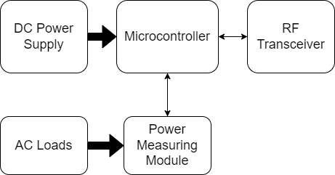

Figure 3.: Block diagram of a unit in the microgrid

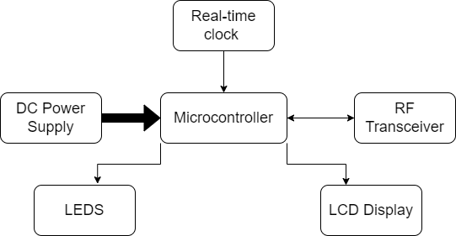

Figure 3.: Block diagram of the Intelligent Power Source Selector

The Intelligent Power Source Selector (IPSS) system is designed to improve the stability and efficiency of a microgrid while reducing the environmental impact and cost incurred. The system collects power consumption information from various units in the microgrid via radio frequency communication. This information is then fed into the algorithm that also considers environmental factors and the current cost of electricity of each available power source.

Based on these factors, the algorithm determines the most suitable power source to use to supply the microgrid with electricity. The IPSS then switches the power source to the most suitable one, thus improving the overall efficiency and reliability of the microgrid.

### SCHEMATIC DIAGRAM OF A UNIT IN THE MICROGRID

The power measuring module (PZEM-004T) measures the power consumption of the unit and sends it to the IPSS system via radio frequency communication. Figure 3.3 shows the circuit diagram of a unit in the microgrid.

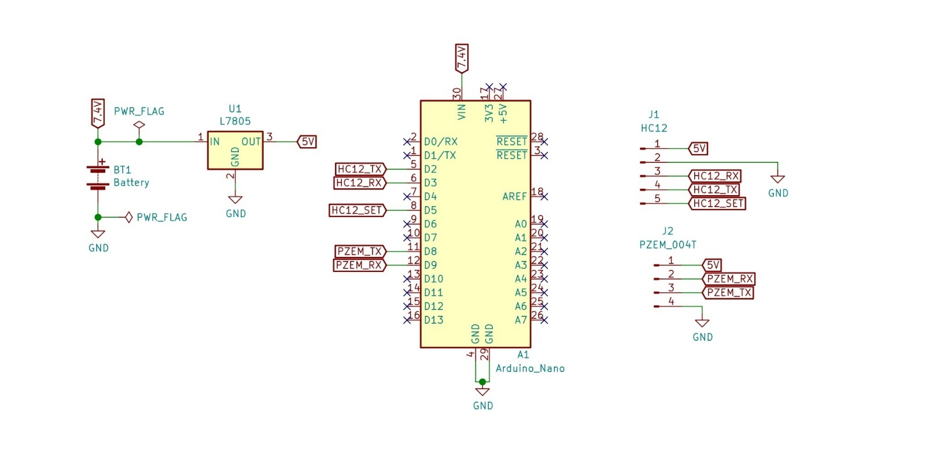

Figure 3.: Schematic diagram of a unit in the microgrid

### SCHEMATIC DIAGRAM OF THE IPSS SYSTEM

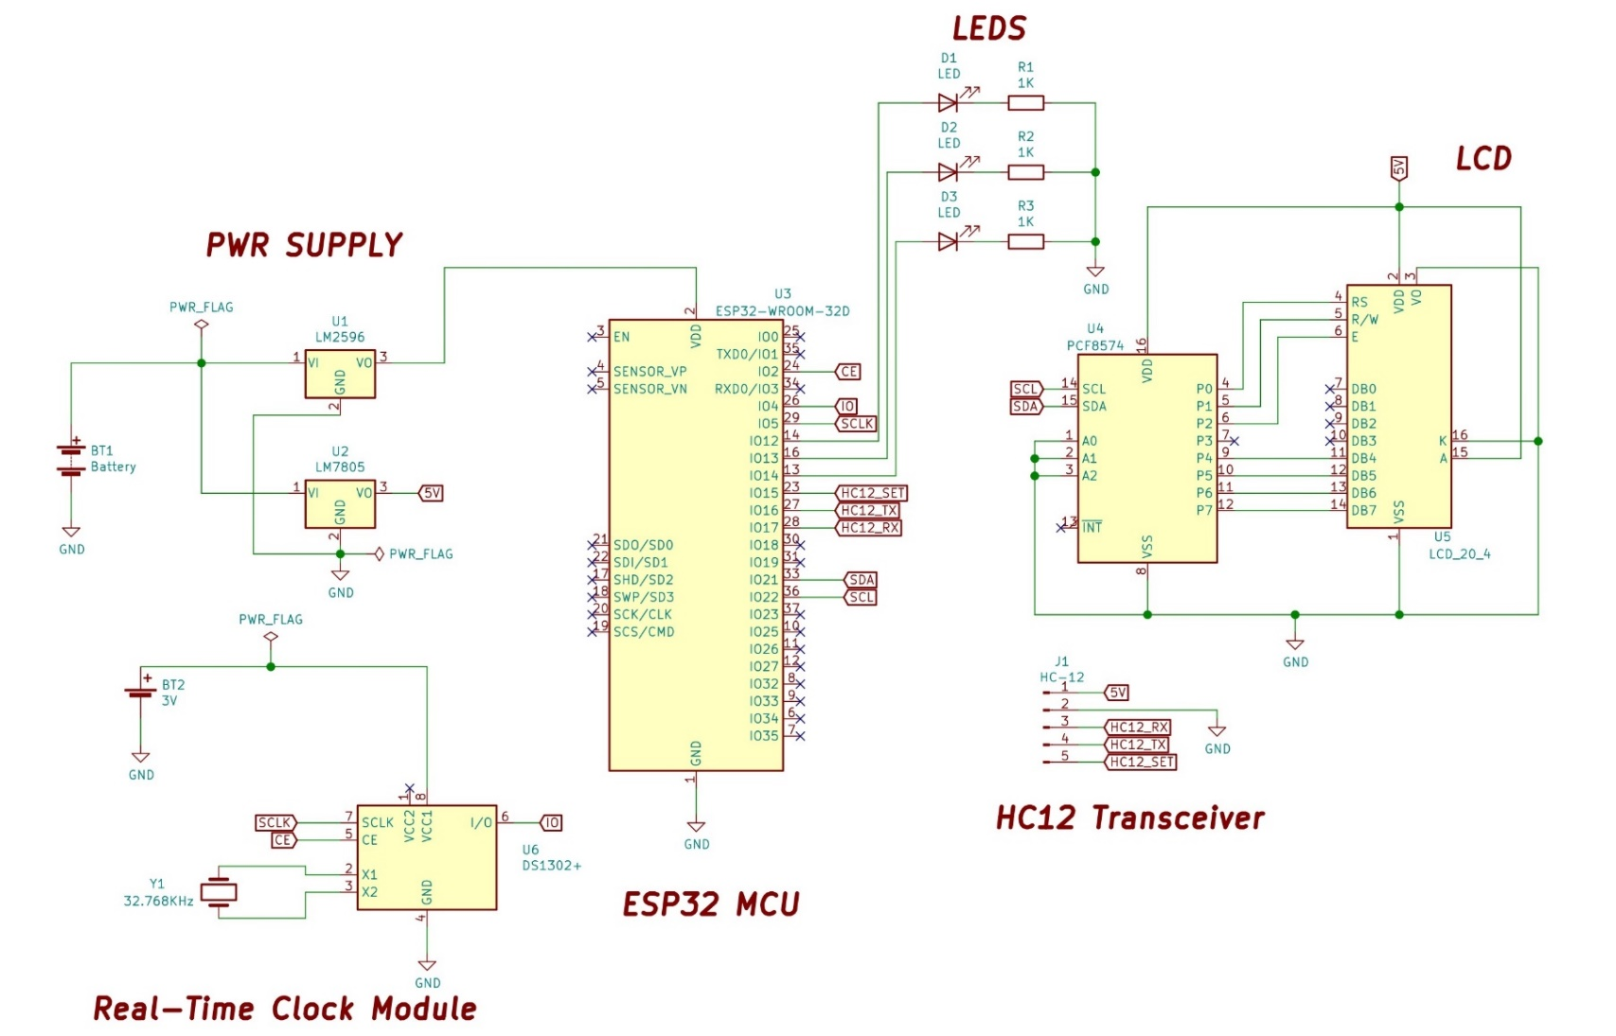

Figure 3.: Schematic diagram of the Intelligent Power Source Selector

## SYSTEM HARDWARE COMPONENTS

This section discusses the working principle of each component used in the microgrid system and how they are connected to form the hardware. It also explains the working principle of each component and how they contribute to the functioning of the system. The section is divided into two parts, with the first part discussing the components used in a unit of the microgrid which consists of:

1. Arduino Nano Development board
2. PZEM-004Tv30 Metering module
3. HC-12 transceiver module
4. Power supply

The second part of the section focuses on the Intelligent Power Source Selector, which is an essential component of the microgrid system. It is composed of:

1. ESP32 Microcontroller
2. 20 x 4 Liquid Crystal Display (LCD)
3. DS1302 Real-Time Clock (RTC) module
4. HC-12 transceiver module
5. LEDs
6. Power Supply

By explaining the working principle of each component in detail, the section aims to provide a comprehensive understanding of the microgrid system’s hardware and how it works.

### Arduino Nano Development Board

The Arduino Nano Development board is a compact and versatile development board that is widely used in various DIY and professional electronics projects. It is based on the ATmega328P microcontroller, which is a popular choice among microcontroller enthusiasts due to its low cost and high performance.

It has 14 digital input/output pins, which can be used to communicate with other electronic devices. It also has 8 analog inputs, which are used to measure and convert analog signals into digital data.

The microcontroller is powered by a 5V DC voltage, which can be supplied through its input voltage pin that can accept a range of 7-12V DC voltage. It has a 16MHz Quartz crystal that serves as its clock source, providing precise timing and synchronization for its operations.

To program the Arduino Nano Microcontroller, the Arduino Integrated Development Environment (IDE) is used. The IDE is a software application that allows developers to write, compile, and upload code to the microcontroller. The IDE is based on the processing programming language, which is a simplified version of the Java programming language. Figure 3.5 shows the image of an Arduino Nano Development board.

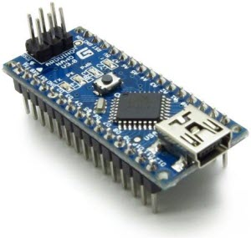

Figure 3.: Arduino Nano Development board (Arduino, 2021)

Table 3.: Specifications of Arduino Nano Microcontroller

|  |  |
| --- | --- |
| **Specification** | **Value** |
| Microcontroller | ATmega328P |
| Operating Voltage | 5V |
| Input Voltage | 7-12V |
| Digital I/O Pins | 14 |
| PWM Outputs | 6 |
| Analog Input Pins | 8 |
| DC current per I/O Pin | 40mA |
| Flash Memory | 32 KB |
| SRAM | 2 KB |
| EEPROM | 1 KB |
| Clock Speed | 16 MHz |

In the microgrid system, the Arduino Nano Microcontroller is responsible for gathering power consumption information from a unit in the microgrid. It is connected to the PZEM-004Tv30 metering module and the HC-12 transceiver module through its digital and analog input/output pins. The metering module provides power consumption data to the microcontroller, which is then transmitted wirelessly to the Intelligent Power Source Selector through the HC-12 transceiver module.

### PZEM-004Tv30 metering module

The PZEM-004Tv30 is an AC single-phase digital power meter designed for measuring and displaying real-time information on power consumption, voltage, current, power factor, and energy usage. It has a built-in transformer that allows it to measure up to 220V and 100A current. The meter has a compact size and is easy to install, making it ideal for monitoring power consumption in homes, factories, and other applications.

The PZEM-004Tv30 uses a serial communication protocol, UART (Universal Asynchronous Receiver/Transmitter) to transmit data to a microcontroller, such as the Arduino Nano. UART is a popular asynchronous communication protocol used to transfer data between two devices. The protocol uses a baud rate of 9600 and sends data in 9-byte frames. The first byte is a header byte that indicates the start of a frame, followed by 6 data bytes, and 2 checksum bytes. The data bytes contain information on voltage, current, power, and energy, while the checksum bytes are used to verify the integrity of the data.

To receive data from the PZEM-004Tv30, the Arduino Nano microcontroller is connected to the metering module through its digital input/output pins. The microcontroller sends a command byte to the metering module to request data, and the module responds by sending a 9-byte frame containing the requested information. The microcontroller then extracts the relevant data from the frame and processes it for transmission to the Intelligent Power Source Selector through the HC-12 transceiver module. Figure 3.6 shows the image of the PZEM-004Tv30 Metering module.

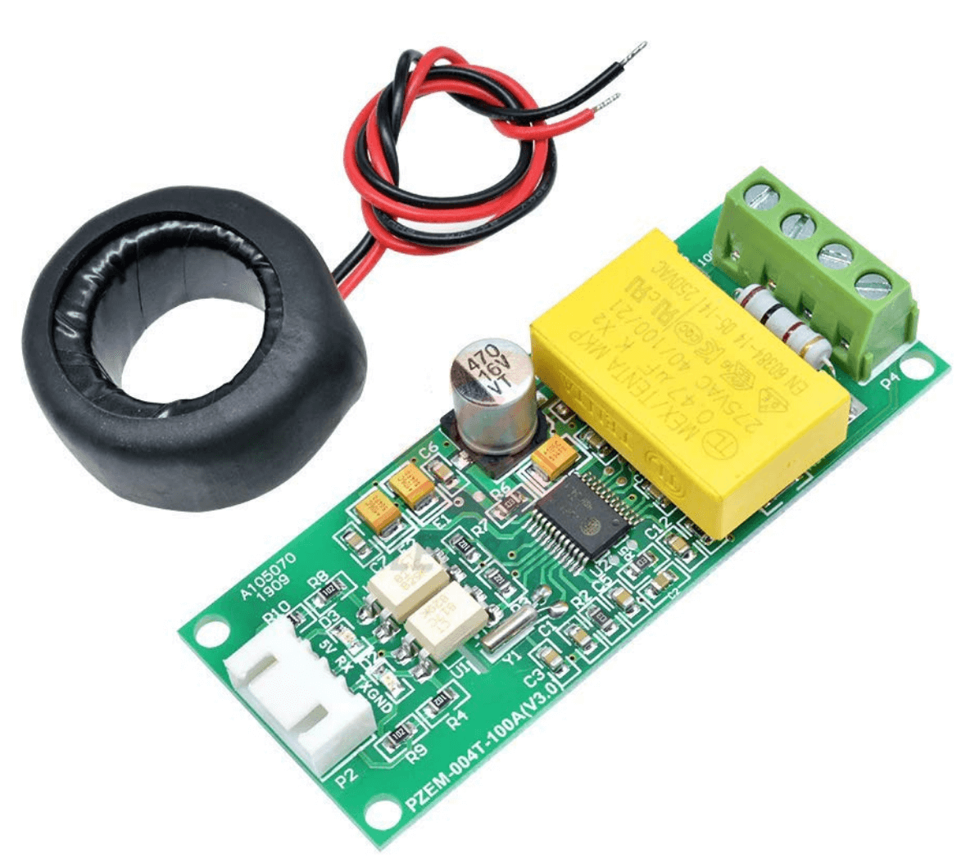

Figure 3.: PZEM-004Tv30 Metering module (InnovatorsGuru, 2018)

Table 3.: Specification of PZEM-004Tv30 Metering module

|  |  |
| --- | --- |
| **Specification** | **Value** |
| Voltage Range | 80-260V AC |
| Current Range | 0-100A AC |
| Active Power Range | 0-22KW |
| Frequency Range | 45-45Hz |
| Voltage Accuracy | ±1% |
| Current Accuracy | ±2% |
| Power Factor Accuracy | ±2% |
| Communication Protocol | UART |

The PZEM-004Tv30 metering module is an important component in the microgrid system as it allows for the measurement and monitoring of power consumption in a unit. It is connected to the Arduino Nano Microcontroller through its communication protocol, UART, and provides real-time data on voltage, current, power factor, and energy usage. This data is then transmitted wirelessly to the Intelligent Power Source Selector through the HC-12 transceiver module for further analysis and control.

### HC-12 Transceiver module

The HC-12 is a wireless serial communication module that allows for long-range communication between two microcontrollers or other electronic devices. It is a cost-effective solution that operates on the 433MHz frequency band and has a range of up to 1 kilometer in open space.

The HC-12 transceiver module is based on the SI4463 chip from Silicon Labs, which is a highly integrated wireless radio transceiver that supports a variety of modulation types and data rates. It has a low power consumption, high sensitivity, and high interference immunity, making it ideal for use in wireless communication applications.

The HC-12 module has a built-in antenna and supports a serial communication protocol, which allows it to be connected directly to a microcontroller or other electronic device through its RX and TX pins. It also has a SET pin for configuring the module.

The module can be configured using AT commands, which can be sent through the serial interface. These commands can be used to set the frequency, power level, data rate, and other parameters of the module. The HC-12 module also supports a transparent transmission mode, which allows it to transmit and receive data without any additional processing or encoding.

The HC-12 transceiver module is commonly used in a variety of applications including remote control, wireless sensor networks, telemetry, and remote monitoring. In the microgrid system, the HC-12 module is used to transmit data wirelessly from the Arduino Nano Microcontroller to the Intelligent Power Source Selector, which allows for remote monitoring and control of the microgrid system. Figure 3.7 shows the image of the HC-12 transceiver module.

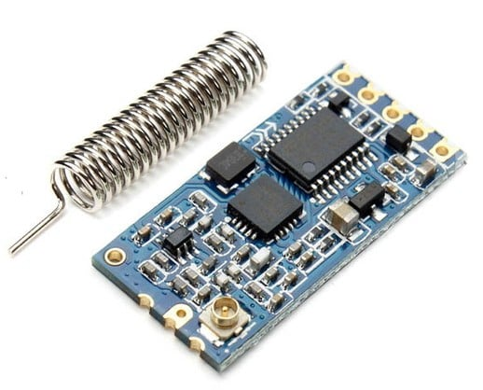

Figure 3.: HC-12 Transceiver Module (All About Circuits, 2016)

Table 3.: Specification of the HC-12 transceiver module

|  |  |
| --- | --- |
| **Specification** | **Value** |
| Frequency Range | 433.4 – 473.0 MHz (with 100 communication channels with a stepping of 400 kHz) |
| Operating Voltage | 3.2 – 5.5 V DC |
| Operating Current | < 100mA (transmission), < 30mA (reception) |
| Transmission Power | 100mW (20dB) maximum |
| Communication Distance | Up to 1km in open space |
| Modulation | GFSK (Gaussian Frequency Shift Keying) |
| Data Rate | 1.2 kbps, 2.4kbps, 4.8 kbps, 9.6 kbps, 19.2 kbps, 38.4 kbps, and 100 kbps |
| Interface | UART |

### Power Supply of a unit in the microgrid

The power supply of the unit in the microgrid consists of two lithium-ion batteries in series and a 5V voltage regulator. The Arduino Nano microcontroller is designed to operate on a voltage range of 7 – 12V, and since two fully charged lithium-ion batteries in series can provide a voltage of around 8.4V, they are suitable for the Arduino Nano.

The HC-12 transceiver module, on the other hand, requires a stable 5V power supply, and hence a voltage regulator is used to step down the voltage from the batteries to 5V. The voltage regulator also ensures that the voltage remains stable even as the batteries discharge.

The lithium-ion batteries used are a type of rechargeable battery that are known for their high energy density, low self-discharge, and long cycle life. They are a popular choice for portable electronic devices due to their lightweight and compact size. In the microgrid system, the two batteries are connected in series to increase the voltage output while maintaining the same capacity.

The 5V voltage regulator used is a linear regulator. A linear regulator is a simple device that works by dissipating excess energy as heat to maintain a constant output voltage. The linear regulator works by comparing the output voltage to a reference voltage and adjusting the resistance in the circuit to maintain a constant output voltage. As the output voltage increases, the regulator reduces the resistance in the circuit, which causes the excess energy to be dissipated as heat. Similarly, as the output voltage decreases, the regulator increases the resistance in the circuit to maintain a constant output voltage.

The power supply is a critical component of the microgrid system, and its reliability is essential for the system's overall performance. The use of lithium-ion batteries and a voltage regulator ensures a stable and reliable power supply for the Arduino Nano and HC-12 transceiver module, enabling them to function optimally and transmit data wirelessly over long distances. Figure 3.8 and Figure 3.9 shows the image of an L7805 voltage regulator and Lithium-ion batteries respectively.

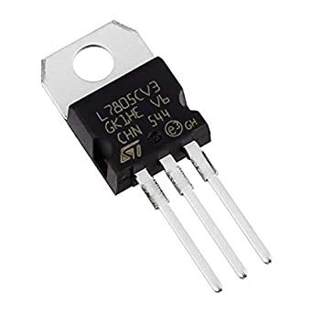

Figure 3.: L7805 5V voltage regulator (Get Electronic, 2023)

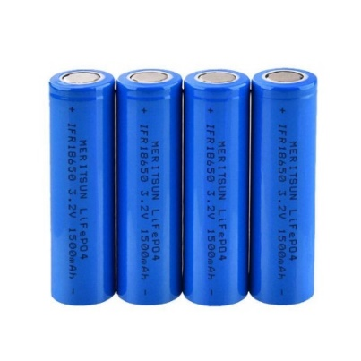

Figure 3.: Lithium-ion batteries (VTC Power, 2020)

Table 3.: Specification of L7805 voltage regulator

|  |  |
| --- | --- |
| **Specification** | **Value** |
| Input Volage range | 7V – 35V |
| Output voltage | 5V ± 2% |
| Output current | Up to 1.5A |
| Dropout voltage | 2V |
| Operating temperature range | 0°C to 125°C |
| Thermal resistance (Junction-to-case) | 5°C/W |
| Package | TO-220 |

### 

### ESP32 Microcontroller

The ESP32 is a low-cost, low-power consumption microcontroller that is designed for use in IoT applications. It is a dual-core microcontroller that features Wi-Fi and Bluetooth connectivity, making it an ideal choice for wireless communication applications. The ESP32 is manufactured by Espressif Systems, and it is based on the Xtensa LX6 microprocessor.

The ESP32 microcontroller features two 32-bit Tensilica Xtensa LX6 microprocessors that run at up to 240 MHz. The microcontroller also has 520 KB of SRAM and 4 MB of flash memory for program storage. In addition to this, the ESP32 features various peripherals such as SPI, I2C, UART, I2S, ADC, and DAC.

One of the most notable features of the ESP32 is its built-in Wi-Fi and Bluetooth capabilities. The microcontroller features a 2.4 GHz Wi-Fi transceiver, which supports both client and access point modes. The Bluetooth capabilities include support for Bluetooth Classic and Bluetooth Low Energy (BLE).

The ESP32 is also designed to be very power-efficient, with various power management features that help to minimize power consumption. It also supports battery operation and deep sleep modes, making it an ideal choice for battery-powered applications.

Programming the ESP32 can be done using a variety of programming languages and development environments, including the Arduino IDE, MicroPython, and the Espressif IoT Development Framework (ESP-IDF). The microcontroller also has built-in support for OTA (over-the-air) firmware updates, making it easy to update the software running on the device remotely.

The ESP32 microcontroller plays a crucial role in the intelligent power source selector of the microgrid system. It is responsible for receiving and processing data from the HC-12 transceiver module, which receives power consumption information from the units in the microgrid. The ESP32 is also connected to a Real-Time Clock (RTC) module, which helps it keep track of the time of day.

The ESP32 uses the data received from the HC-12 transceiver and the RTC module to run an algorithm that selects the most appropriate power source to supply the microgrid. The algorithm takes into account the total power consumption of the microgrid, the time of day, and the availability of the different power sources. The available power sources in the microgrid include solar panels, wind turbines, generator and the main grid.

By selecting the most appropriate power source to supply the microgrid, the ESP32 helps to optimize the use of available resources and minimize the overall cost of power consumption. It also ensures that the microgrid has a reliable and stable power supply, even in situations where there may be fluctuations in the availability of power from different sources.

The ESP32's processing power, built-in Wi-Fi and Bluetooth capabilities, and power management features make it an ideal choice for the intelligent power source selector in the microgrid system. Figure 3.10 shows the image of an ESP32 microcontroller.

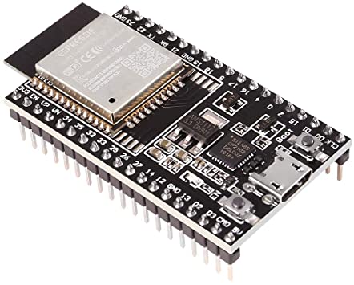

Figure 3.: ESP32 Microcontroller (Espressif Systems, 2016)

Table 3.: Specifications of the ESP32 microcontroller

|  |  |
| --- | --- |
| **Feature** | **Description** |
| Processor | Dual-core Tensilica LX6 Microprocessor |
| Clock Speed | Up to 240 MHz |
| Memory | 520 KB SRAM, 4 MB flash memoy |
| Connectivity | Wi-Fi (802.11 b/g/n), Bluetooth Classic and BLE |
| Peripherals | SPI, I2C, UART, I2S, ADC, DAC |
| Power Management | Deep sleep modes, power-efficient design |
| Programming Languages | C/C++, MicroPython |
| OTA Update | Built-in support for over-the-air firmware updates |
| Input Voltage | 2.2V - 3.6V |

### 20X4 Liquid Crystal Display (LCD)

The Intelligent power source selector uses a 20x4 LCD to display the current time, total power consumption of the units in the microgrid and the source(s) selected to supply the microgrid with. This means that the display has 20 columns and 4 rows, allowing it to display up to 80 characters at once.

The LCD display is a type of flat panel display that uses liquid crystals to control the polarization of light passing through a layer of liquid crystal material. The LCD display used in the Intelligent power source selector is a character LCD, meaning that it can only display characters rather than graphics or images.

The LCD display is typically controlled by a microcontroller or other digital device, using a dedicated interface such as the HD44780 LCD controller. The controller communicates with the LCD display through a series of parallel or serial data lines, and provides commands and data to the display to control what is displayed on the screen.

In the Intelligent power source selector, the LCD display is connected to the ESP32 microcontroller, which controls what is displayed on the screen. The ESP32 communicates with the LCD display using the I2C protocol, which is a type of serial communication protocol.

To display the current time, the ESP32 retrieves the time from the RTC module and formats it into a string that can be displayed on the LCD screen. The ESP32 then sends this string to the LCD display, which displays it in the appropriate location on the screen.

To display the total power consumption of the units in the microgrid, the ESP32 retrieves the power consumption information from the HC-12 transceiver and formats it into a string that can be displayed on the LCD screen. The ESP32 then sends this string to the LCD display, which displays it in the appropriate location on the screen.

Finally, to display the source(s) selected to supply the microgrid, the ESP32 runs its algorithm to determine which source(s) to use, and then formats this information into a string that can be displayed on the LCD screen. The ESP32 then sends this string to the LCD display, which displays it in the appropriate location on the screen. Figure 3.11 shows the image of a 20 x 4 Liquid Crystal Display (LCD).

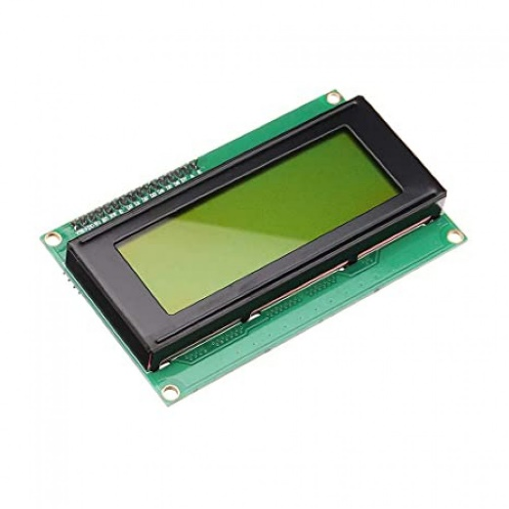

Figure 3.: 20 x 4 LCD Display (Electron Components, 2023)

Table 3.: Specification of the 20 x 4 LCD Display

|  |  |
| --- | --- |
| **Specification** | **Value** |
| Display type | Character LCD |
| Display size | 20 characters x 4 lines |
| Display controller | HD44780 or equivalent |
| Interface | I2C or parallel |
| Character set | ASCII or custom |
| Operating voltage | 5V |
| Power consumption | < 1W |
| Operating temp. | -20°C to 70°C |

### DS1302 Real-time clock module

The DS1302 RTC module uses a 3-wire interface that includes a data line, a clock line, and a reset line. The data line is bidirectional and is used to transfer data between the microcontroller and the RTC module. The clock line is used to synchronize the transfer of data between the microcontroller and the RTC module. The reset line is used to reset the RTC module to its initial state, which is useful when initializing the module or when recovering from an error.

The DS1302 RTC module communicates using a binary coded decimal (BCD) format, which allows for easy conversion of the time and date data to a human-readable format. The module also has a built-in trickle charger, which allows it to operate using a small backup battery to keep the time and date accurate even when the main power source is disconnected.

To interface the DS1302 RTC module with a microcontroller, such as the ESP32 in the Intelligent power source selector, the microcontroller sends commands to the RTC module using the 3-wire interface to set the time and date, and to retrieve the current time and date. The microcontroller can also configure the RTC module to generate an interrupt signal at a specific time, which can be used to trigger an action, such as turning on/off a specific power source in the Intelligent power source selector. Figure 3.12 shows the image of the DS1302 Real Time Clock module used in this project.

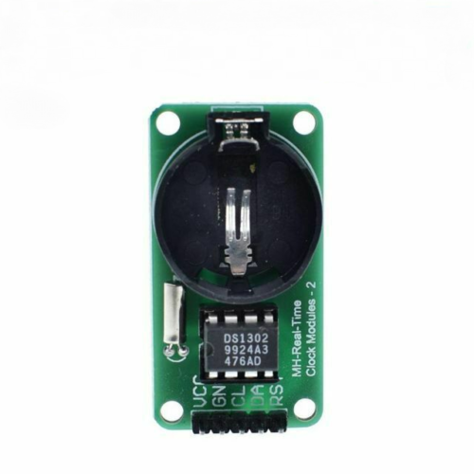

Figure 3.: DS1302 RTC module (Robofactory, 2023)

Table 3.: Specification of the DS1302 RTC module

|  |  |
| --- | --- |
| **Specification** | **Value** |
| Power supply | 2.0V – 5.5V |
| Operating Current | < 300nA (battery backup), <1.5mA (Active) |
| Interface | 3-Wire (data, clock, reset) |
| Operating temperature | -40°C - 85°C |
| Clock Accuracy | ±2 ppm |

### LEDS

LED stands for Light Emitting Diode. It is a semiconductor device that emits light when an electric current flows through it. LEDs are commonly used as indicators to provide visual feedback on the status of a device or system.

In the Intelligent Power Source Selector (IPSS), LEDs are used to indicate the sources selected to supply the microgrid. The ESP32 microcontroller, which controls the selection of power sources, sends a signal to the appropriate LED to turn it on when a particular source is selected.

For example, if the solar panels and the grid are selected as sources to supply the microgrid, the ESP32 would send signals to the LEDs corresponding to the solar panels and the grid, causing them to light up. This provides a clear visual indication to the user that these sources have been selected to supply the microgrid.

LEDs are ideal for this application because they are small, low power and provide a bright, highly visible light. They are also durable and long-lasting, making them well-suited for use in electronic devices and systems. Figure 3.13 shows the image of Light Emitting Diodes (LEDs).

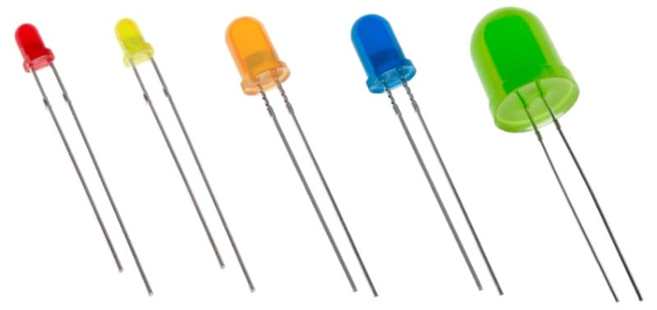

Figure 3.: Light Emitting Diodes (LEDs) (Wiltronics, 2019)

### Power Supply (IPSS)

The power supply of the IPSS includes two Lithium-ion batteries, a Buck converter, and a 5V voltage regulator. The batteries are used to power IPSS. The Buck converter is used to step down the voltage from the batteries to provide a stable 3.3V supply for the ESP32 microcontroller. The 5V voltage regulator is used to step down the voltage from the batteries to provide a stable 5V supply for the LCD display and other components that require 5V.

A Buck converter, also known as a step-down converter, is a type of DC-DC converter that steps down the input voltage to a lower output voltage. It is a switching converter that uses an inductor and a capacitor to store and transfer energy between the input and output. The Buck converter is an efficient way to step down the battery voltage to a lower voltage for the ESP32 microcontroller. It is designed to minimize power loss and heat generation, making it an efficient choice for battery-powered applications.

The 5V voltage regulator is a linear regulator that provides a stable 5V output voltage, regardless of any fluctuations in the input voltage. This ensures that components that require a stable 5V supply, such as the LCD display, operate reliably and without any issues.

The power supply of the IPSS is designed to provide stable and reliable power to the microcontroller and other components. Figure 3.14 shows the image of the LM2596 buck converter.

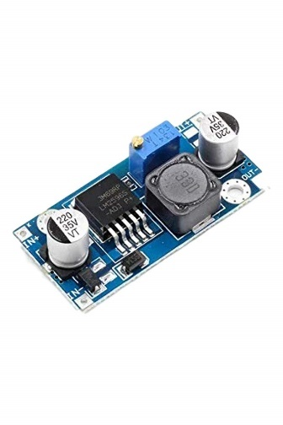

Figure 3.: LM2596 buck converter (ElectroPeak, 2022)

Table 3.: Specifications of the LM2596 buck converter

|  |  |
| --- | --- |
| **Specification** | **Value** |
| Input Voltage range | 3.2V – 40V |
| Output Voltage range | 1.25V – 35V |
| Output Current | 3A |
| Switching frequency | 150kHz |
| Efficiency | Up to 92% |
| Adjustment | 25-Turn Trimpot |

## SYSTEM SOFTWARE COMPONENT

The software component of the project is designed to improve the efficiency and reliability of a microgrid by selecting the most appropriate power source based on the total power consumption and time of the day. The system software consists of three main components:

1. Data Receiver Module
2. An Intelligent Power Source Selector (IPSS) Algorithm
3. A Real-Time Clock Module

### Data Receiver Module

The Data Receiver Module is implemented using an HC-12 radio frequency (RF) module connected to an ESP32 microcontroller. The HC-12 RF module operates in the 433 MHz frequency range, and is capable of wireless data transmission over long distances (up to 1 km in open areas).

The ESP32 microcontroller is responsible for controlling the HC-12 module and processing the incoming data from the nodes. The ESP32 is programmed using the Arduino Integrated Development Environment (IDE) and the C++ programming language, and includes libraries for controlling the HC-12 module and handling the incoming data.

The HC-12 module is configured to operate in transparent serial communication mode, allowing the ESP32 to receive data from the nodes as a stream of bytes. Each node in the microgrid is assigned a unique address, which is included in the data transmission along with the power consumption data.

The Intelligent Power Source Selector sends periodic queries to the nodes to request for updated power consumption data. The ESP32 microcontroller is responsible for sending these queries over the HC-12 module and processing the incoming responses.

Once the data is received from the nodes, the ESP32 aggregates the power consumption data and sends it to the IPSS Algorithm for processing. The power consumption data is stored in a buffer, which is periodically cleared to prevent data overflow.

The Data Receiver Module plays a critical role in the system by providing the necessary data on power consumption across the microgrid. The combination of the HC-12 RF module and the ESP32 microcontroller allows for reliable and efficient wireless communication with the nodes. Figure 3.15 shows the block diagram of the data receiver module.

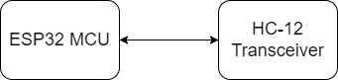

Figure 3.: Data Receiver Module

### Intelligent Power Source Selector (IPSS) Algorithm

The Intelligent Power Source Selector (IPSS) Algorithm is the core component of the software system. It is responsible for selecting the most appropriate power source for the microgrid based on the total power consumption and time of day.

The IPSS Algorithm considers the available power sources in the microgrid and their power outputs, as well as the energy demand of the microgrid throughout the day. The microgrid has three power sources: solar, wind, and diesel generator. Each power source has a different power output profile throughout the day.

The IPSS Algorithm first checks the current time of day, which is obtained from the Real-Time Clock (RTC) Module. Based on the time, the algorithm determines the power output of each power source. During high energy demand periods, the algorithm selects the most powerful and efficient source to meet the energy demand. For example, if the demand is high and it is currently during the day when the sun is shining, the algorithm will select the solar power source, which has the highest power output during daylight hours. If the solar power source's power output is exceeded, the algorithm will supplement it with the wind power source or diesel generator or both, depending on which combination gives the least cost and meets the demand.

During low energy demand periods, the algorithm selects the most cost-effective and efficient source. For example, if the demand is low and it is currently during the night when the wind is blowing, the algorithm will select the wind power source, which has a high-power output during the night. If the wind power source's power output is exceeded, the algorithm will supplement it with the solar power source or diesel generator or both, depending on which combination gives the least cost and meets the demand.

The IPSS algorithm continuously monitors the energy demand and adjusts the power source selection accordingly. It is implemented in software using C++ programming language and takes input from the Data Receiver Module and the Real-Time Clock (RTC) Module. It provides output to the Power Source Selector Module and is designed to be flexible and easily adaptable to changes in the microgrid's power sources or energy demand. The diesel generator is used only as a last resort to complement the power output of the other sources, due to its environmental impact.

### Real-time clock module

The Real-Time Clock (RTC) Module is responsible for keeping track of the current time and date. It is used by the IPSS Algorithm to determine the appropriate power source based on the time of day. The RTC Module is connected to an ESP32 microcontroller which runs a web server that allows for dynamic time changes to model different times of day during testing.

The software system consists of the Data Receiver Module, the Intelligent Power Source Selector (IPSS) Algorithm, and the Real-Time Clock (RTC) Module. The Data Receiver Module receives power consumption data from the nodes in the microgrid and sends it to the IPSS Algorithm for processing. The IPSS Algorithm selects the most appropriate power source for the microgrid based on the total power consumption and time of day, while the RTC Module keeps track of the current time and date for use by the IPSS Algorithm. Together, these components work to improve the efficiency and reliability of the microgrid.

Figure 3.16 shows the flowchart of the software component of the IPSS system.

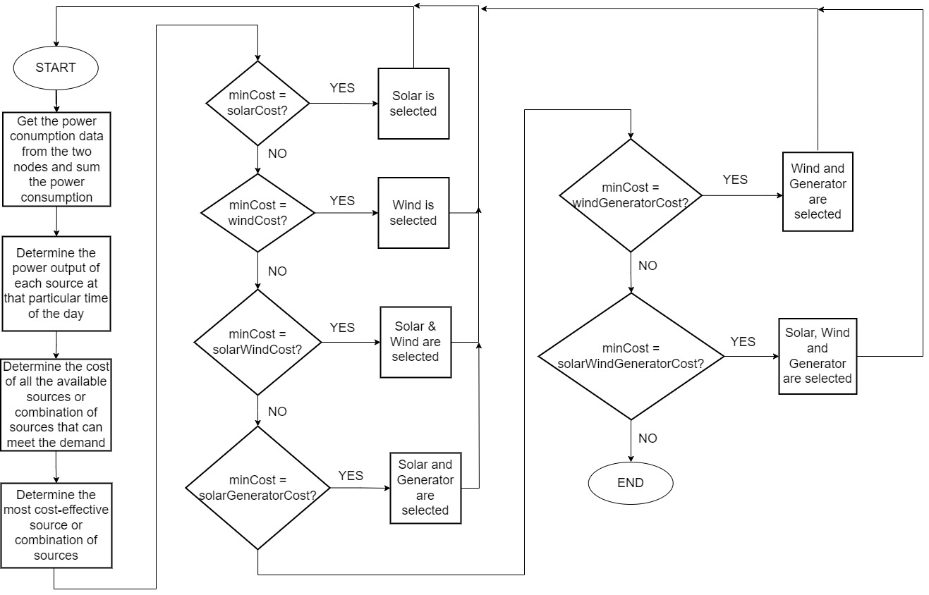

Figure 3.: Flowchart of the software component of the IPSS system

# 

# results and discussions

## INTRODUCTION

In this chapter, the results obtained from the implementation of the Intelligent Power Source Selector (IPSS) algorithm in a microgrid will be presented and discussed. The purpose of this chapter is to evaluate the performance of the IPSS system in managing multiple power sources in a microgrid and to determine the effectiveness of the algorithm in reducing the overall cost of energy.

The results will be presented in different scenarios, each with a different energy demand and power profile of power sources. The analysis of the results will include the comparison of cost of energy incurred when using the IPSS system with that incurred when using a diesel generator for the entire duration. Additionally, the performance of the system in selecting the most cost-effective power source will be evaluated.

The results presented in this chapter will provide insight into the effectiveness of the IPSS algorithm in managing power sources in a microgrid and highlight the potential benefits of using renewable energy sources in reducing the cost of energy.

## IPSS SYSTEM PERFORMANCE

The IPSS system was tested with a microgrid consisting of solar panels, wind turbines, and a diesel generator. The energy demand of the microgrid varied throughout the day, with peak hours occurring in the evening hours. The power output profiles of the sources used in the microgrid are shown in Table 4.1:

Table 4.: Power output profiles of the sources used in the microgrid

|  |  |  |  |
| --- | --- | --- | --- |
| **Hour** | **Solar (W)** | **Wind (W)** | **Diesel Generator (W)** |
| 0 | 0 | 20 | 50 |
| 1 | 0 | 20 | 50 |
| 2 | 0 | 25 | 50 |
| 3 | 0 | 35 | 50 |
| 4 | 0 | 40 | 50 |
| 5 | 0 | 45 | 50 |
| 6 | 20 | 50 | 50 |
| 7 | 30 | 50 | 50 |
| 8 | 35 | 50 | 50 |
| 9 | 40 | 50 | 50 |
| 10 | 40 | 45 | 50 |
| 11 | 45 | 40 | 50 |
| 12 | 50 | 35 | 50 |
| 13 | 50 | 30 | 50 |
| 14 | 50 | 30 | 50 |
| 15 | 50 | 35 | 50 |
| 16 | 40 | 40 | 50 |
| 17 | 30 | 50 | 50 |
| 18 | 20 | 50 | 50 |
| 19 | 0 | 50 | 50 |
| 20 | 0 | 50 | 50 |
| 21 | 0 | 45 | 50 |
| 22 | 0 | 30 | 50 |
| 23 | 0 | 20 | 50 |

Based on the data presented in Table 4.1, it can be seen that the solar power output is highest during daylight hours, while the wind power output is highest during periods of high wind speed. The diesel generator is only used when during periods of low renewable energy and when it is necessary to meet the energy demand of the microgrid.

The IPSS system was able to effectively manage the power sources to meet the energy demand of the microgrid while minimizing the cost of energy. The system was able to switch between the different power sources based on their output, cost, and the energy demand of the microgrid.

To provide a basis for cost comparison, it was assumed that the cost of solar was 40 naira per watt-hour (Wh), the cost of wind power was 60 naira per watt-hour (Wh) and the cost of diesel generator was 100 naira per watt-hour (Wh). Table 4.2 shows a typical scenario for a 24-hour period:

Table 4.: IPSS system performance for a 24-hour period

|  |  |  |  |
| --- | --- | --- | --- |
| **Hour** | **Power Demand (W)** | **Power Source Selected** | **Cost (Naira)** |
| 0 | 10 | Wind | 600 |
| 1 | 15 | Wind | 900 |
| 2 | 10 | Wind | 600 |
| 3 | 20 | Wind | 1,200 |
| 4 | 20 | Wind | 1,200 |
| 5 | 20 | Wind | 1,200 |
| 6 | 80 | Wind + Diesel Generator | 12,800 |
| 7 | 80 | Solar + Wind | 8,000 |
| 8 | 80 | Solar + Wind | 8,000 |
| 9 | 30 | Solar | 1,200 |
| 10 | 30 | Solar | 1,200 |
| 11 | 30 | Solar | 1,200 |
| 12 | 40 | Solar | 1,600 |
| 13 | 35 | Solar | 1,400 |
| 14 | 30 | Solar | 1,200 |
| 15 | 35 | Solar | 1,400 |
| 16 | 40 | Solar | 1,600 |
| 17 | 70 | Solar + Wind | 7,000 |
| 18 | 80 | Wind + Diesel Generator | 12,800 |
| 19 | 80 | Wind + Diesel Generator | 12,800 |
| 20 | 90 | Wind + Diesel Generator | 14,400 |
| 21 | 90 | Wind + Diesel Generator | 14,400 |
| 22 | 50 | Wind + Diesel Generator | 8,000 |
| 23 | 30 | Wind + Diesel Generator | 4,800 |

Based on the presented data in Table 4.2, it is evident that the IPSS system is capable of effectively managing multiple power sources in a microgrid. The system was able to select the appropriate power source or combination of power sources to meet the energy demand of the microgrid while minimizing the cost of energy.

The IPSS system was able to switch between different power sources based on their output, cost, and the energy demand of the microgrid. For example, during daylight hours, the system selected solar power as the power source, while during periods of high wind speed, the system selected wind power. During peak hours, the system utilized a combination of solar and wind power to meet the high energy demand of the microgrid.

The IPSS system was also able to reduce the cost of energy compared to using a diesel generator for the entire duration. The system switched to the diesel generator only during periods of low renewable energy output when it was necessary to meet the energy demand of the microgrid.

## COMPARISON WITH TRADITIONAL POWER GENERATION METHODS

The cost of using the Intelligent Power Selector System was compared to that of using a diesel generator to power the microgrid for a period of 24 hours. The comparison was done to assess the cost effectiveness of using renewable energy sources with an IPSS system compared to traditional power generation methods. Table 4.3 shows the results of the comparison.

Table 4.: Comparison between IPSS system and Traditional Power generation methods

|  |  |  |  |
| --- | --- | --- | --- |
| **Hour** | **Power Demand (W)** | **Cost using IPSS (Naira)** | **Cost using Diesel Generator Only (Naira)** |
| 0 | 10 | 600 | 1,000 |
| 1 | 15 | 900 | 1,500 |
| 2 | 10 | 600 | 1,000 |
| 3 | 20 | 1,200 | 2,000 |
| 4 | 20 | 1,200 | 2,000 |
| 5 | 20 | 1,200 | 2,000 |
| 6 | 80 | 12,800 | 16,000 |
| 7 | 80 | 8,000 | 16,000 |
| 8 | 80 | 8,000 | 16,000 |
| 9 | 30 | 1,200 | 3,000 |
| 10 | 30 | 1,200 | 3,000 |
| 11 | 30 | 1,200 | 3,000 |
| 12 | 40 | 1,600 | 4,000 |
| 13 | 35 | 1,400 | 3,500 |
| 14 | 30 | 1,200 | 3,000 |
| 15 | 35 | 1,400 | 3,500 |
| 16 | 40 | 1,600 | 4,000 |
| 17 | 70 | 7,000 | 14,000 |
| 18 | 80 | 12,800 | 16,000 |
| 19 | 80 | 12,800 | 16,000 |
| 20 | 90 | 14,400 | 18,000 |
| 21 | 90 | 14,400 | 18,000 |
| 22 | 50 | 8,000 | 5,000 |
| 23 | 30 | 4,800 | 3,000 |
|  | TOTAL | 118,300 | 178,500 |

Table 4.3 shows the results of the comparison between the two methods. The table shows that the total cost incurred when using the IPSS system was 118,300 naira, while the total cost incurred when using the diesel generator was 178,500 naira. This indicates that using the IPSS system is significantly more cost-effective than using diesel generator.

The higher cost of using a diesel generator is mainly due to the cost of fuel required to operate it continuously for 24 hours. In contrast, the IPSS system efficiently manages the power sources based on their output, cost, and energy demand of the microgrid, reducing the need for constant power supply from a diesel generator.

These results demonstrate the economic benefits of using renewable energy sources with an IPSS system in a microgrid compared to traditional power generation methods. Not only does it lead to cost savings, but it also contributes to reducing carbon emissions and promoting sustainable energy practices. Figure 4.1 shows pictures of the working prototype of the Intelligent power source selector selecting the most cost-effective source or combination of sources in different scenarios.

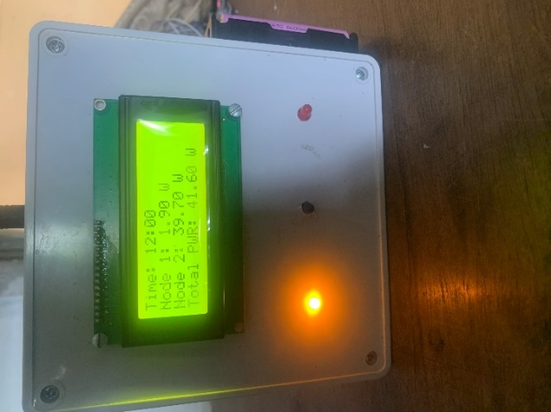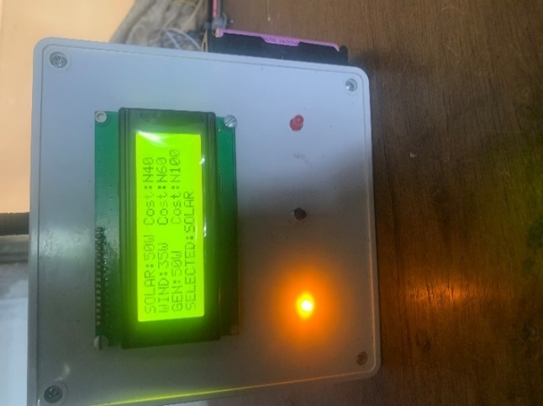

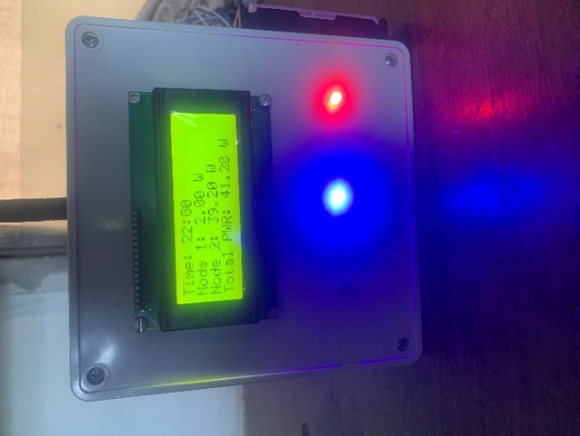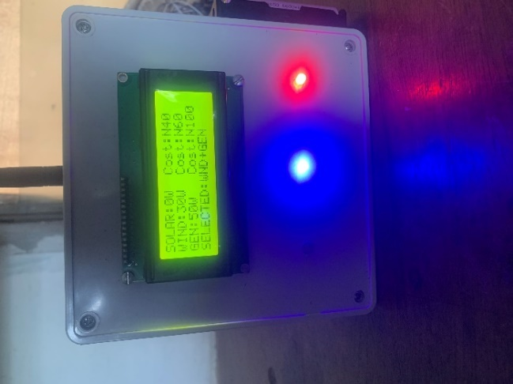

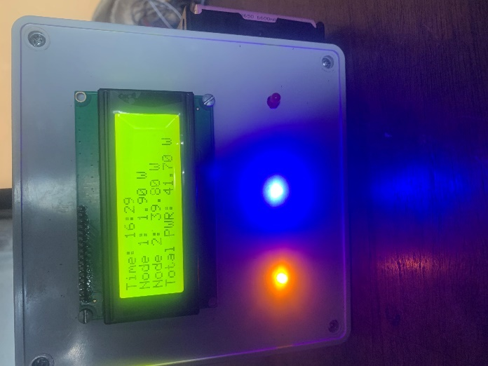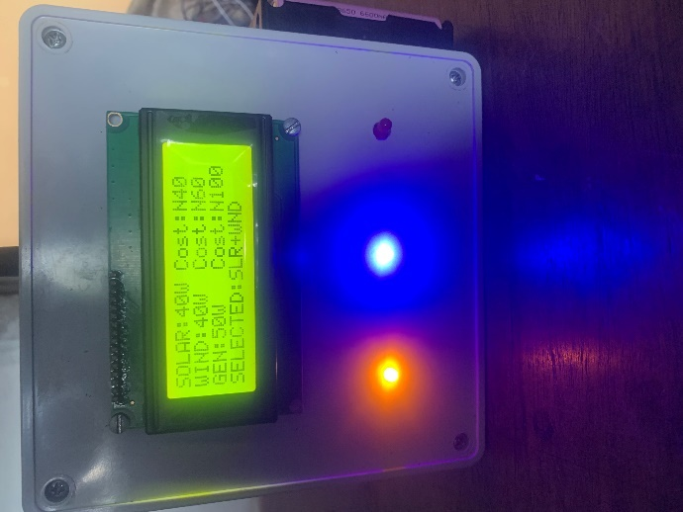

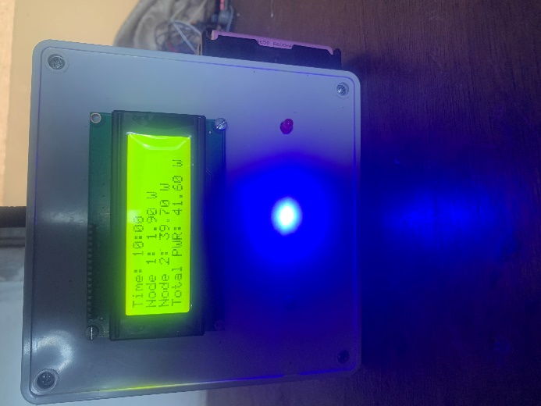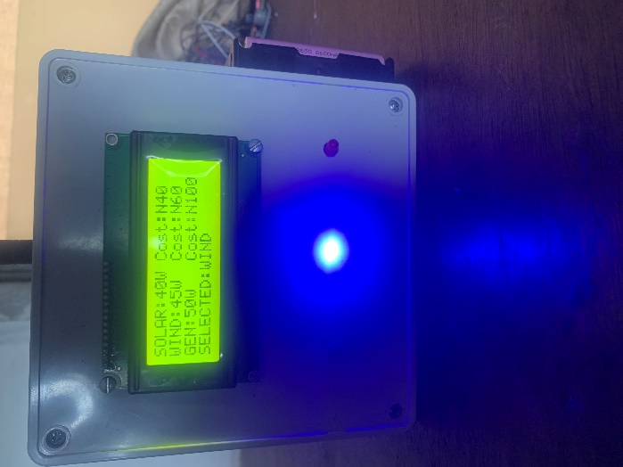

Figure 4.: Working prototype of the Intelligent Power Source Selector

# 

# conclusion and recommendation

## CONCLUSION

In this project, an Intelligent Power Source Selector (IPSS) algorithm that can effectively manage power sources in a microgrid has been developed. The algorithm considers the available power sources, their output profiles throughout the day, and the energy demand of the microgrid to select the most appropriate power source or combination of power sources.

The algorithm was implemented in C++ programming language and tested with different power demand scenarios. The results showed that the algorithm is effective in reducing cost of energy by selecting the most cost-effective power source to supply the microgrid.

The IPSS is a promising solution for effectively managing power sources in a microgrid and reducing the cost of energy. As renewable energy sources continue to become more widely adopted, the implementation of intelligent algorithms such as IPSS will become increasingly important to ensure the efficient and sustainable use of these energy sources.

## RECOMMENDATION

The IPSS algorithm can be further improved to enhance its performance in managing power sources in a microgrid. A few recommendations are:

1. To generate more accurate solar power output profile, the modelling of solar power source irradiation can be improved using normal distribution.
2. For a more accurate wind power output profile, modelling of the wind power source using Weibull distribution can be considered.
3. Incorporating energy storage devices such as batteries into the microgrid to store excess energy from the power sources and use it during peak demand periods.
4. Integrating real-time weather data can better predict the power output of renewable energy sources and improve the accuracy of the IPSS algorithm.
5. Using a machine learning algorithm to improve the decision-making process of the IPSS system.

# appendix

1. **LIST OF MATERIALS USED**

For successful implementation of the project, the table below shows the materials used.

|  |  |  |
| --- | --- | --- |
| **S/N** | **MATERIAL/COMPONENT NAME** | **QUANTITY** |
| 1 | Arduino Nano Microcontroller | 2 |
| 2 | ESP32 Microcontroller | 1 |
| 3 | HC-12 Transceiver Module | 3 |
| 4 | 20 x 4 LCD Module | 1 |
| 5 | Real-time clock (RTC) Module | 1 |
| 6 | LEDS | 3 |
| 7 | Plastic Enclosures | 3 |
| 8 | PZEM-004Tv30 Metering Module | 2 |
| 9 | Electric Bulb | 1 |
| 10 | 13A socket | 1 |

Table 5.: List of Materials Used

**B. IPSS ALGORITHM HEADER FILE**

#ifndef IPSS_H_INCLUDED

#define IPSS_H_INCLUDED

#include <stdint.h>

enum powerSource

{

SOLAR = 0,

WIND,

SOLAR_WIND,

SOLAR_GEN,

WIND_GEN,

SOLAR_WIND_GEN,

INVALID

};

class IPSS

{

private:

uint16_t _generatorOutput;

const uint16_t* _solarOutput;

const uint16_t* _windOutput;

uint16_t _solarCost;

uint16_t _windCost;

uint16_t _generatorCost;

bool IsSolarAvailable(uint8_t currHour);

bool IsWindAvailable(uint8_t currHour);

bool IsGeneratorAvailable(void);

bool IsSolarSuitable(uint8_t currHour,float powerDemand);

bool IsWindSuitable(uint8_t currHour,float powerDemand);

bool IsGeneratorSuitable(uint8_t currHour,float powerDemand);

bool IsSolarAndWindSuitable(uint8_t currHour,float powerDemand);

bool IsSolarAndGeneratorSuitable(uint8_t currHour,float powerDemand);

bool IsWindAndGeneratorSuitable(uint8_t currHour,float powerDemand);

bool IsSolarWindAndGeneratorSuitable(uint8_t currHour,float powerDemand);

public:

IPSS(const uint16_t* solarOutput,const uint16_t* windOutput,uint16_t generatorOutput,

const uint16_t solarCost,const uint16_t windCost,const uint16_t generatorCost);

powerSource SelectPowerSource(uint8_t currHour,float powerDemand);

};

#endif // IPSS_H_INCLUDED

**C. IPSS ALGORITHM SOURCE FILE**

#include "IPSS.h"

#define INFINITY 65535

uint16_t IPSS::GetMinimum(uint16_t num1,uint16_t num2,uint16_t num3,

uint16_t num4,uint16_t num5,uint16_t num6)

{

uint16_t minimum = num1;

if(num2 < minimum)

{

minimum = num2;

}

if(num3 < minimum)

{

minimum = num3;

}

if(num4 < minimum)

{

minimum = num4;

}

if(num5 < minimum)

{

minimum = num5;

}

if(num6 < minimum)

{

minimum = num6;

}

return minimum;

}

IPSS::IPSS(const uint16_t* solarOutput,const uint16_t* windOutput,uint16_t generatorOutput,

const uint16_t solarCost, const uint16_t windCost,const uint16_t generatorCost)

{

_solarOutput = solarOutput;

_windOutput = windOutput;

_generatorOutput = generatorOutput;

_solarCost = solarCost;

_windCost = windCost;

_generatorCost = generatorCost;

}

bool IPSS::IsSolarAvailable(uint8_t currHour)

{

return _solarOutput[currHour] > 0;

}

bool IPSS::IsWindAvailable(uint8_t currHour)

{

return _windOutput[currHour] > 0;

}

bool IPSS::IsGeneratorAvailable(void)

{

return _generatorOutput > 0;

}

bool IPSS::IsSolarSuitable(uint8_t currHour,float powerDemand)

{

bool isSuitable = false;

if(IPSS::IsSolarAvailable(currHour) && _solarOutput[currHour] >= powerDemand)

{

isSuitable = true;

}

return isSuitable;

}

bool IPSS::IsWindSuitable(uint8_t currHour,float powerDemand)

{

bool isSuitable = false;

if(IPSS::IsWindAvailable(currHour) && _windOutput[currHour] >= powerDemand)

{

isSuitable = true;

}

return isSuitable;

}

bool IPSS::IsSolarAndWindSuitable(uint8_t currHour,float powerDemand)

{

bool isSuitable = false;

if(IPSS::IsSolarAvailable(currHour) && IPSS::IsWindAvailable(currHour))

{

if((_solarOutput[currHour] + _windOutput[currHour]) >= powerDemand)

{

isSuitable = true;

}

}

return isSuitable;

}

bool IPSS::IsSolarAndGeneratorSuitable(uint8_t currHour,float powerDemand)

{

bool isSuitable = false;

if(IPSS::IsSolarAvailable(currHour) && IPSS::IsGeneratorAvailable())

{

if((_solarOutput[currHour] + _generatorOutput) >= powerDemand)

{

isSuitable = true;

}

}

return isSuitable;

}

bool IPSS::IsWindAndGeneratorSuitable(uint8_t currHour,float powerDemand)

{

bool isSuitable = false;

if(IPSS::IsWindAvailable(currHour) && IPSS::IsGeneratorAvailable())

{

if((_windOutput[currHour] + _generatorOutput) >= powerDemand)

{

isSuitable = true;

}

}

return isSuitable;

}

bool IPSS::IsSolarWindAndGeneratorSuitable(uint8_t currHour,float powerDemand)

{

bool isSuitable = false;

if(IPSS::IsSolarAvailable(currHour) && IPSS::IsWindAvailable(currHour) && IPSS::IsGeneratorAvailable())

{

if((_solarOutput[currHour] + _windOutput[currHour] + _generatorOutput) >= powerDemand)

{

isSuitable = true;

}

}

return isSuitable;

}

powerSource IPSS::SelectPowerSource(uint8_t currHour,float powerDemand)

{

powerSource selectedSource;

//Calculate the cost of each source

uint16_t solarCost = IPSS::IsSolarSuitable(currHour,powerDemand) ?

_solarCost : INFINITY;

uint16_t windCost = IPSS::IsWindSuitable(currHour,powerDemand) ?

_windCost : INFINITY;

uint16_t solarWindCost = IPSS::IsSolarAndWindSuitable(currHour,powerDemand) ?

(_solarCost + _windCost) : INFINITY;

uint16_t solarGeneratorCost = IPSS::IsSolarAndGeneratorSuitable(currHour,powerDemand) ?

(_solarCost + _generatorCost) : INFINITY;

uint16_t windGeneratorCost = IPSS::IsWindAndGeneratorSuitable(currHour,powerDemand) ?

(_windCost + _generatorCost) : INFINITY;

uint16_t solarWindGeneratorCost = IPSS::IsSolarWindAndGeneratorSuitable(currHour,powerDemand) ?

(_solarCost + _windCost + _generatorCost) : INFINITY;

//Select the power source with the least cost

uint16_t minCost = IPSS::GetMinimum(solarCost,windCost,solarWindCost,solarGeneratorCost,windGeneratorCost,solarWindGeneratorCost);

if (minCost == INFINITY)

{

selectedSource = INVALID;

}

else if (minCost == solarCost)

{

selectedSource = SOLAR;

}

else if (minCost == windCost)

{

selectedSource = WIND;

}

else if (minCost == solarWindCost)

{

selectedSource = SOLAR_WIND;

}

else if (minCost == solarGeneratorCost)

{

selectedSource = SOLAR_GEN;

}

else if (minCost == windGeneratorCost)

{

selectedSource = WIND_GEN;

}

else if (minCost == solarWindGeneratorCost)

{

selectedSource = SOLAR_WIND_GEN;

}

return selectedSource;

}

**D. IPSS ALGORITHM MAIN FILE**

#include "IPSS.h"

#define GENERATOR_OUTPUT 50

const uint16_t SOLAR_OUTPUT[24] = {0,0,0,0,0,0,

20,30,35,40,40,45,

50,50,50,50,40,30,

20,0,0,0,0,0};

const uint16_t WIND_OUTPUT[24] = {20,20,25,35,40,45,

50,50,50,50,45,40,

35,30,30,35,40,50,

50,50,50,45,30,20};

const uint16_t GENERATOR_COST = 100;

const uint16_t SOLAR_COST = 40;

const uint16_t WIND_COST = 60;

//uint8_t currHour = 11;

using namespace std;

IPSS ipss(SOLAR_OUTPUT,WIND_OUTPUT,GENERATOR_OUTPUT,

SOLAR_COST,WIND_COST,GENERATOR_COST);

uint32_t totalPower[24] = {10,15,10,20,20,20,

80,80,80,30,30,30,

40,35,30,35,40,70,

80,80,90,90,50,30};

int main()

{

//srand(20);

cout << "TIME" <<'\t'<< "Total Demand" <<'\t' << "Solar Output" <<'\t'<< "Wind Output"<<'\t'<<"Gen Output"<<'\t'<<"IPSS Selection"<<'\t' <<'\t'<<"Cost"<<endl;

for(int i = 0; i < 24; i++)

{

//totalPower = 1 + (rand() % 100);

cout<< i <<'\t' << totalPower[i] <<'\t' << '\t' << '\t' << SOLAR_OUTPUT[i] << '\t' << '\t' << WIND_OUTPUT[i] << '\t' << GENERATOR_OUTPUT;

ipss.SelectPowerSource(i,totalPower[i]);

}

return 0;

}

# REFERENCES

Abdulgalil, M. A., & Khalid, M. (2019). Enhancing the reliability of a microgrid through optimal size of battery ESS. *IET Generation, Transmission & Distribution*, *13*(9), 1499–1508. https://doi.org/10.1049/iet-gtd.2018.5335

All About Circuits. (2016). *Understanding and Implementing the HC-12 wireless Transceiver* . https://www.allaboutcircuits.com/projects/understanding-and-implementing-the-hc-12-wireless-transceiver-module/

Ani, V. A. (2021). Development of an Intelligent Power Management System for Solar PV-Wind-Battery-Fuel-Cell Integrated System. *Frontiers in Energy Research*, *9*. https://doi.org/10.3389/fenrg.2021.613958

Arduino. (2021). *Arduino Nano*. https://store.arduino.cc/products/arduino-nano

Atwa, Y. M., El-Saadany, E. F., Salama, M. M. A., & Seethapathy, R. (2010). Optimal Renewable Resources Mix for Distribution System Energy Loss Minimization. *IEEE Transactions on Power Systems*, *25*(1), 360–370. https://doi.org/10.1109/TPWRS.2009.2030276

Avikal, S., Singhal, R., Sajwan, R., Tiwari, R. K., & Singh, R. (2020). Selection of best power supply source for telecom towers in remote areas. *International Journal of Mathematical, Engineering and Management Sciences*, *5*(5), 913–925. https://doi.org/10.33889/IJMEMS.2020.5.5.070

Belmokhtar, K., & Higuita Cano, M. (2021). Power Flow Management Algorithm for a Remote Microgrid Based on Artificial Intelligence Techniques. In *AI and Learning Systems - Industrial Applications and Future Directions*. IntechOpen. https://doi.org/10.5772/intechopen.93399

Electron Components. (2023). *LCD 20X4 Alphanumeric Display with Green Backlight*. https://www.electroncomponents.com/LCD-20X4-Display-Alphanumeric-Green

ElectroPeak. (2022). *LM2596 DC-DC Step Down Power Supply Module - Buck Converter*. https://electropeak.com/lm2596

Elsaiah, S., Benidris, M., & Mitra, J. (2016). A method for reliability improvement of microgrids. *2016 Power Systems Computation Conference (PSCC)*, 1–7. https://doi.org/10.1109/PSCC.2016.7540996

Espressif Systems. (2016). *ESP32*. https://docs.espressif.com/projects/esp-idf/en/latest/esp32/hw-reference/esp32/get-started-devkitc.html

Faria, J., Pombo, J., Calado, M., & Mariano, S. (2019). Power Management Control Strategy Based on Artificial Neural Networks for Standalone PV Applications with a Hybrid Energy Storage System. *Energies*, *12*(5), 902. https://doi.org/10.3390/en12050902

Get Electronic. (2023). *L7805*. https://www.getelectronic.net/products/l7805-5v-voltage-regulator

Hosseinzadeh, M., & Salmasi, F. R. (2015). Robust Optimal Power Management System for a Hybrid AC/DC Micro-Grid. *IEEE Transactions on Sustainable Energy*, *6*(3), 675–687. https://doi.org/10.1109/TSTE.2015.2405935

InnovatorsGuru. (2018). *PZEM004Tv30*. https://innovatorsguru.com/pzem-004t-v3/

Katiraei, F., & Iravani, M. R. (2006). Power Management Strategies for a Microgrid With Multiple Distributed Generation Units. *IEEE Transactions on Power Systems*, *21*(4), 1821–1831. https://doi.org/10.1109/TPWRS.2006.879260

Kong, F., & Liu, X. (2016). GreenPlanning: Optimal Energy Source Selection and Capacity Planning for Green Datacenters. *2016 ACM/IEEE 7th International Conference on Cyber-Physical Systems (ICCPS)*, 1–10. https://doi.org/10.1109/ICCPS.2016.7479104

Kumar, A., Singh, R., Cai, Y., & Grijalva, S. (2020). *Smart Home Energy Management System With Optimal Source Selection in a Real-Time Pricing Environment*.

Ma, W. J., Wang, J., Lu, X., & Gupta, V. (2016). Optimal Operation Mode Selection for a DC Microgrid. *IEEE Transactions on Smart Grid*, *7*(6), 2624–2632. https://doi.org/10.1109/TSG.2016.2516566

Robofactory. (2023). *DS1302 Real-Time Clock Module*. https://www.robofactory.co.za/arduino-modules/420-ds1302-real-time-clock-module.html

Trifkovic, M., Sheikhzadeh, M., Nigim, K., & Daoutidis, P. (2012). Hierarchical control of a renewable hybrid energy system. *2012 IEEE 51st IEEE Conference on Decision and Control (CDC)*, 6376–6381. https://doi.org/10.1109/CDC.2012.6426425

VTC Power. (2020). *Li-ion 18650 1300mah 3.7V rechargeable battery* . https://www.vtcbattery.com/li-ion-18650-1300mah-3-7v-rechargeable-battery.html

Wang, S., Liu, J., Liu, Z., Wu, T., Meng, X., & Liu, B. (2016). A hierarchical operation strategy of parallel inverters for efficiency improvement and voltage stabilization in microgrids. *2016 IEEE 2nd Annual Southern Power Electronics Conference (SPEC)*, 1–6. https://doi.org/10.1109/SPEC.2016.7846149

Wang, Y., Liu, P., Liu, D., Deng, F., & Chen, Z. (2021). Enhanced Hierarchical Control Framework of Microgrids With Efficiency Improvement and Thermal Management. *IEEE Transactions on Energy Conversion*, *36*(1), 11–22. https://doi.org/10.1109/TEC.2020.3002670

Wiltronics. (2019). *Diffused LED*. https://www.wiltronics.com.au/product/44940/diffused-led/